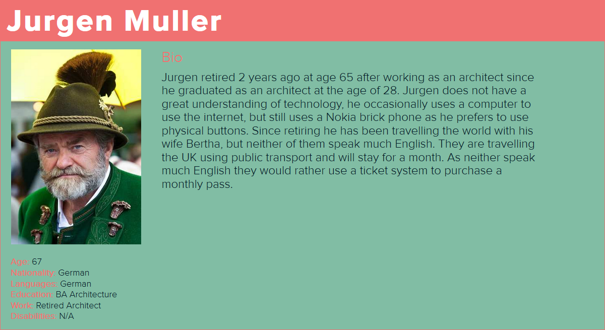

Jurgen has arrived at the transport station after the flight from Berlin and needs to purchase two month passes, one for himself and one for his wife. Jurgen can do this from one of the many ticket machines around the station.

Jurgen approaches a ticket machine and is greeted with a menu asking him to select a language. There are indicators on the screen that show him how to scroll down to find the desired language, Jurgen presses the down arrow button to scroll down the list until he finds German, which he highlights and selects with the press of a button. The interface proceeds and asks which type of ticket he wants, and he again scrolls down with the navigation button to find ‘Passes’. Once selected, the interface asks Jurgen how long the pass needs to be; Jurgen scrolls through numbers 1-30 to select 30 days. Jurgen is asked how many tickets he wants to purchase; Jurgen selects 2. The machine then asks for a payment method; cash or card, and Jurgen selects card as he does not want to use his cash to pay for the tickets. Jurgen is prompted to enter his card into the card reader, and once the card is entered the system recognises Jurgen’s card is European, and is asked whether he would like to pay in pounds, which would be converted to Euros and taken from his account, or directly pay in Euros. Jurgen decides to pay with Euros, and the payment processes and prompts Jurgen to remove his card upon completion. Once the card has been removed, the tickets are printed and ejected from the machine, which Jurgen collects, along with a receipt.

Jurgen and his wife are then able to scan the tickets to get through the barrier onto the train, or scan them to get on the bus. Once the tickets are expired they will no longer be able to use them. The tickets will be checked by a conductor who will occasionally come round and scan the ticket to make sure it is valid.

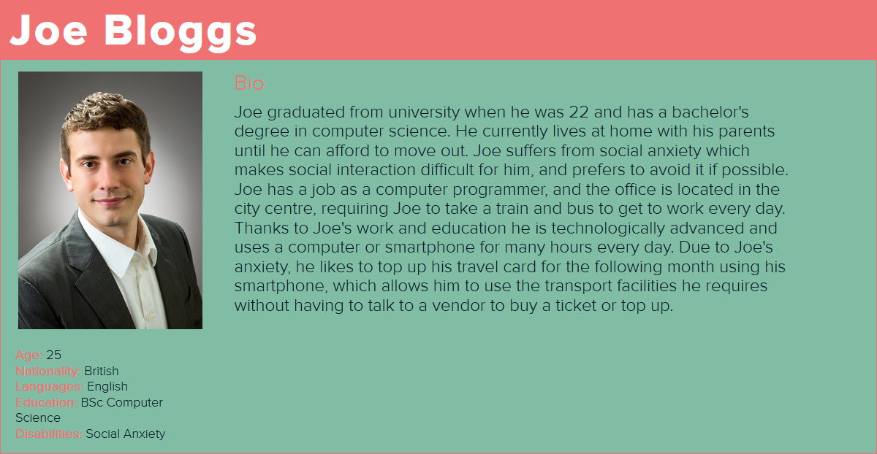It is coming up to the end of the month, and Joe needs to check the funds on his account, and top up if necessary, as he will have to travel to work the following morning. Fortunately, Joe can do this from the comfort of his own home with the transport app.

Joe opens the transport app on his smartphone and logs in to his account with his username and password. Joe is greeted when his login is successful. He opens the navigation menu chooses the option to view the balance on his account. Joe is shown his remaining balance, which is £8.40. Joe usually needs around £60 on his account to last the entire month; therefore Joe needs to top up his balance. He again opens the navigation menu and chooses the option to top up his balance. Joe is asked how much he would like to top up by and enters £60 as he wants to make sure he has a little excess at the end of the month. He presses the continue button and is asked whether he would like to use a current payment method, as his debit card details are saved from previous payments, or a new payment method. Joe selects current payment method and is asked for his 3 digit CVV security code from his debit card. The payment is processed and taken from the bank, and his account balance has been updated accordingly. He then opens the navigation menu and logs out of his account.

Joe goes to the station in the morning to do his morning commute from home to work which involves one train and a bus he starts off with arriving at the train station with his card and then places his card on the barrier to open them with his card. the barriers open and then he proceeds through the barrier and then gets on the the train and this is then checked by the conductor who scans the card and sees it's valid to travel. he then departs from the train and scans his card again to get out of the train station. he then scan the card again to get onto the bus and then again to get off.

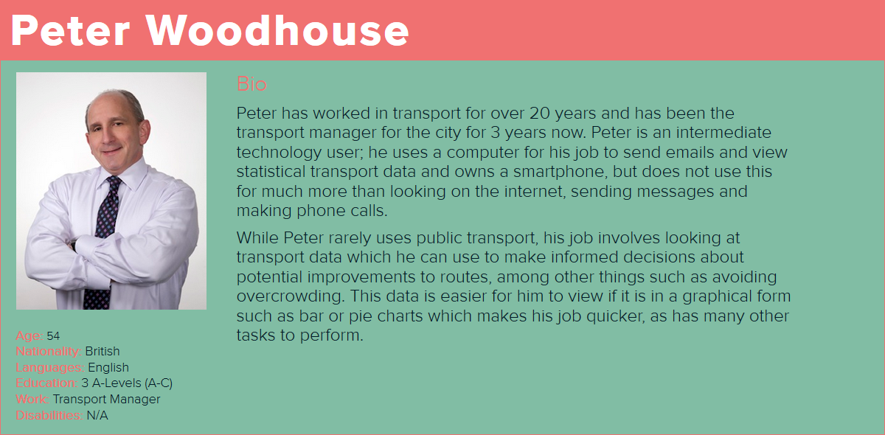

Peter has heard reports that a journey in the city is becoming far too overcrowded on Monday’s at 5:00pm and has resulted people getting hurt. Peter needs to look further into this to see if there is an easy solution to this.

Peter opens the admin panel and logs in on his computer. He navigates to the reports section and selects a customer report. To get the data Peter needs, he enters the date, time and train that has reports of overcrowding. Peter finds that the number of people getting on the train on Monday at 5:00pm is higher than is expected. Peter navigates to the routes and times data and it shows that the same train has departure times at 4:00pm, 5:00pm and 6:00pm and then generates reports for the other departures too. He finds that the other departures are far less crowded than the 5:00pm departure. From viewing this data Peter changes the timetable to allow extra departures for the same journey at 4:30pm and 5:30pm to give the 5:00pm more chance of being less crowded.